// Assignment 1-1

function Maximum(no1:number,no2:number,no3:number):number

{

var Max:number;

if(no1>no2&&no3)

{

Max=no1;

return Max;

}

else if(no2>no1&&no3)

{

Max=no2;

return Max;

}

else{

Max=no3;

return Max;

}

}

var ans:number;

ans=Maximum(23,89,6);

console.log("Maximum number is:"+ans);

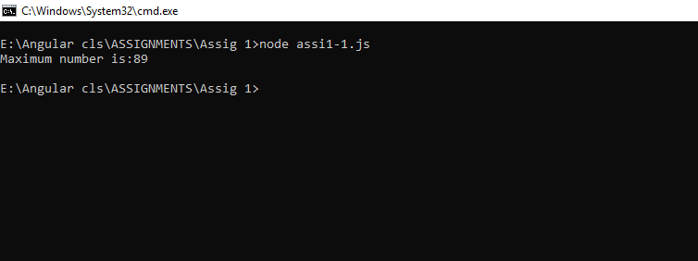

//Assignment 1-2

function Area(radius:number,pi:number=3.14)

{

var ans:number;

ans=pi\*radius\*radius;

console.log("Area of circle is:"+ans);

}

Area(5);

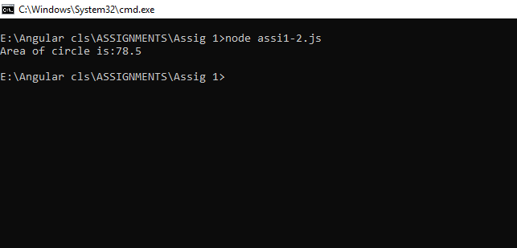

//assignment 1-3

function Displayfactors(no1:number)

{

for(var i=1;i<no1;i++)

{

if(no1%i==0)

{

console.log(i);

}

}

}

Displayfactors(20);

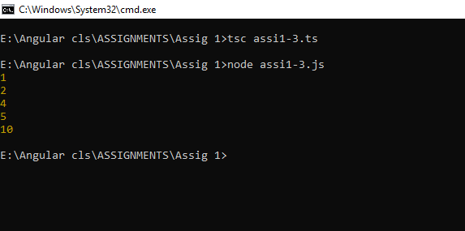

// assignment1-4

function Primeno(no1:number)

{

var cnt:number=0;

for(var i=2;i<no1;i++)

{

if(no1%i==0)

{

cnt++;

}

}

if(cnt>0)

{

console.log("it is not prime number");

}

else{

console.log("it is a prime number");

}

}

Primeno(11);

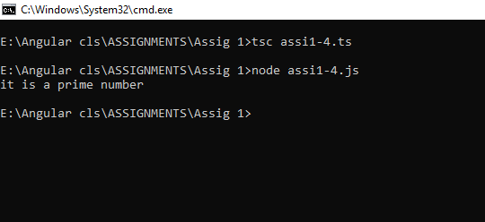

// assignment 1-5

function fibo(no1:number)

{

var ans:number=0;

var a:number=1;

var b:number=0;

console.log(a);

while(ans<no1)

{

ans=a+b;

b=a;

a=ans;

console.log(ans);

}

}

fibo(21);

